**EDUNET FOUNDATION-Class Exercise Notebook**

**Demo: Lets try Linear Regression on GUI Platform**

Step 1: Sign in into Microsoft Azure Machine Learning Studio (classic) and create workspace.

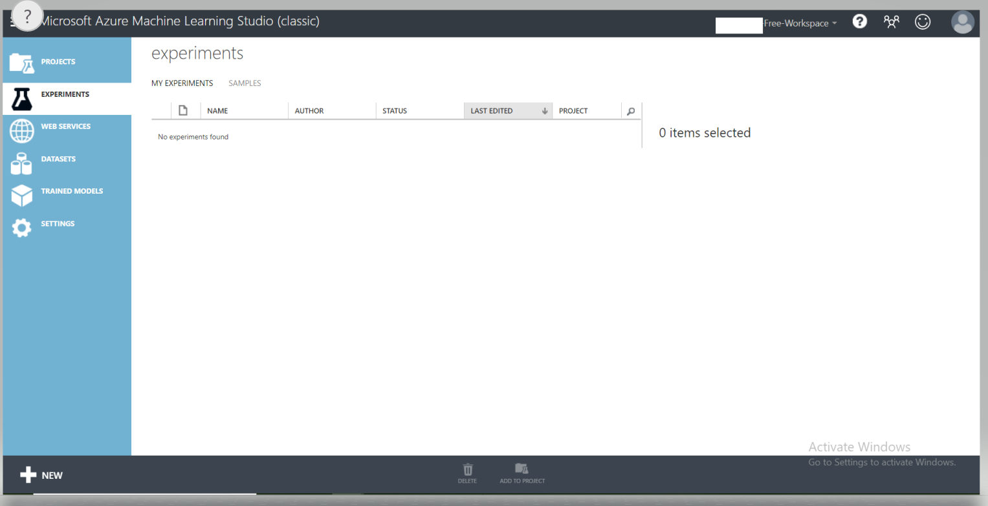

Step 2: First select **Experiment** and then **New** at the bottom of the page.

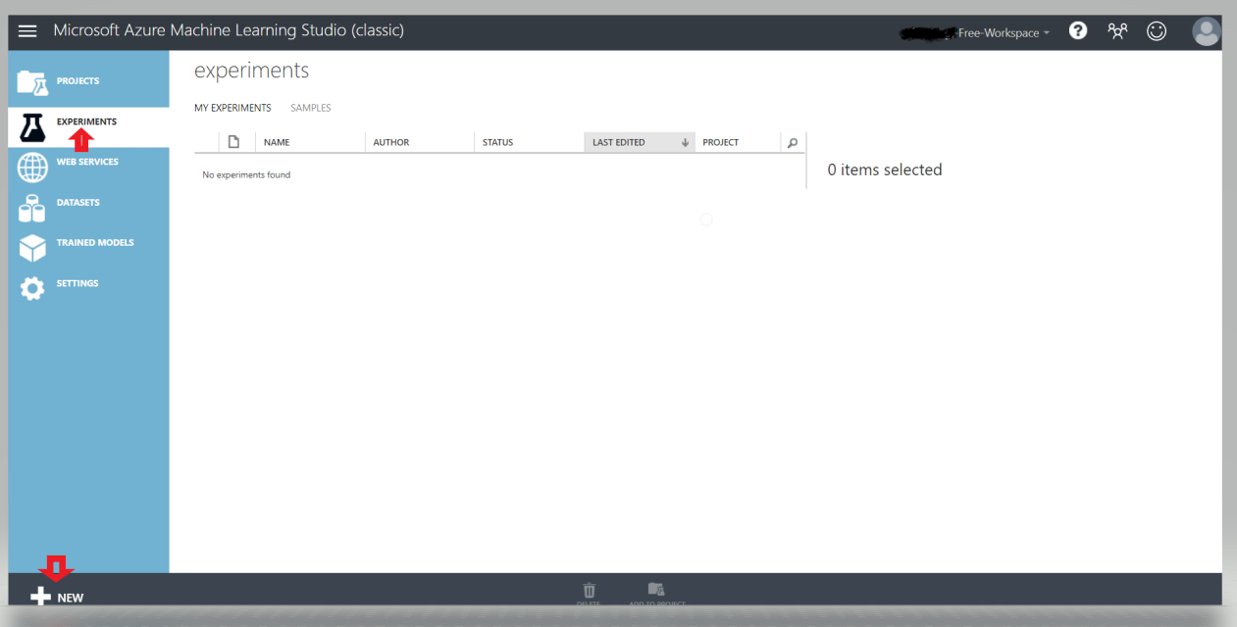

Step 3: Select Blank Experiment.

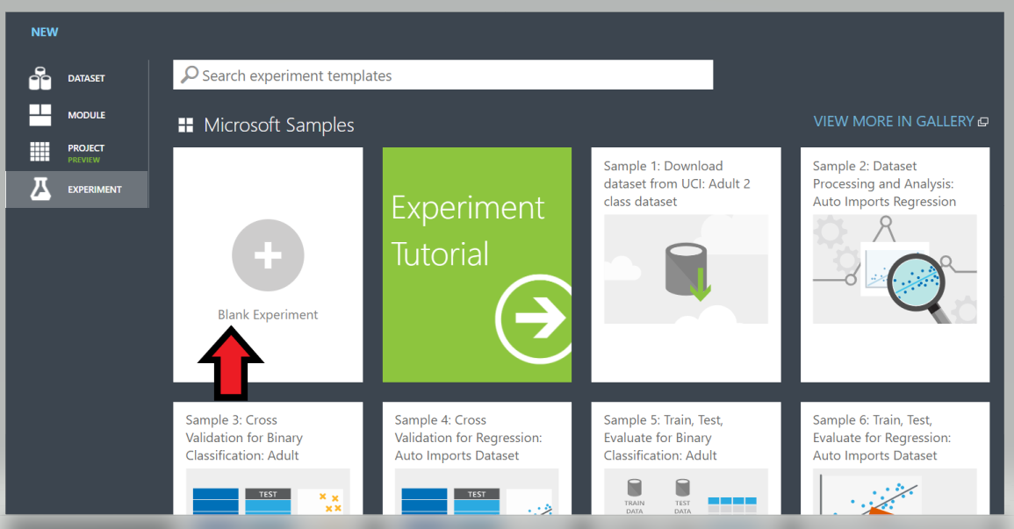

Step 4: Give the title for the project.

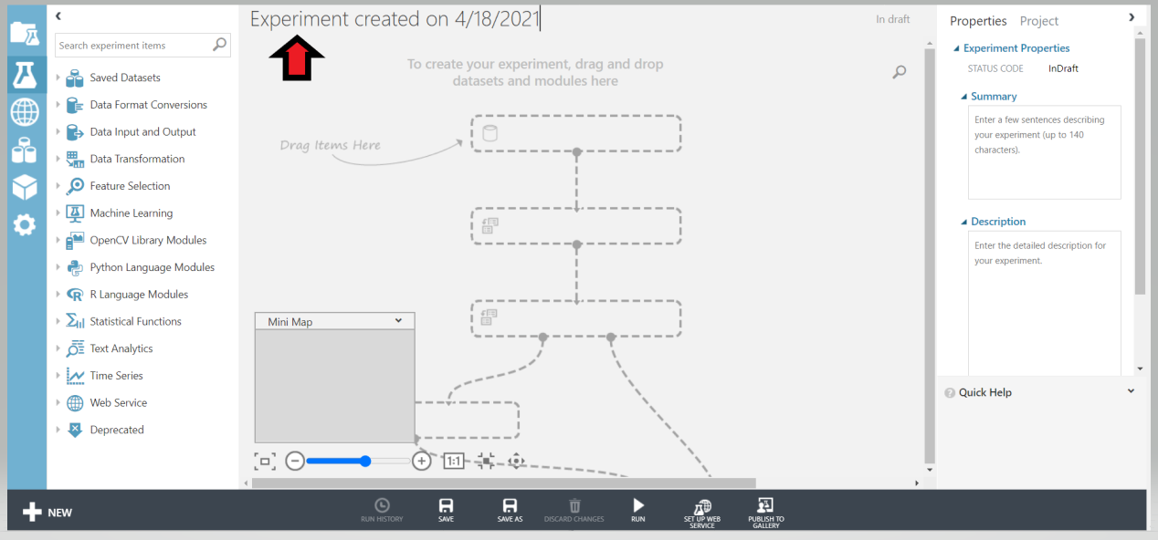

Step 5: Set below mentioned settings along with defining task specific blocks in Workspace:

1. Use Automobile Price Data
2. Select columns of interest
3. Clean missing data
4. Splitting raw data into train and test sets.
5. Place train model block
6. Connect Linear Regression ML block to train model block as depicted below

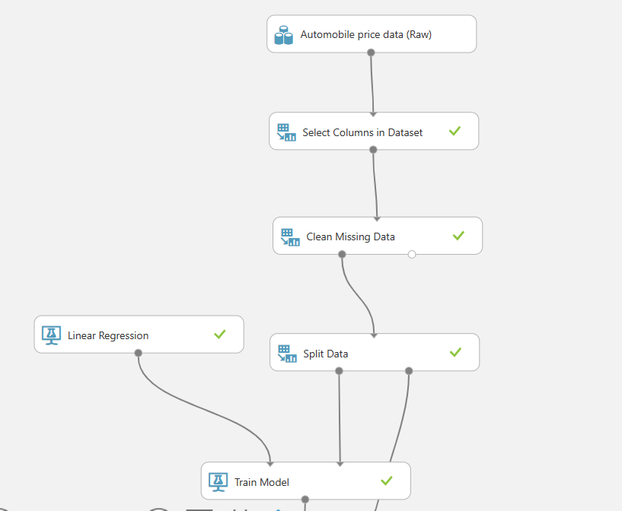

1. Place and connect the Score block to measure the performance of the trained model on unseen test data.
2. Place and connect the evaluation block.
3. Run the whole GUI model

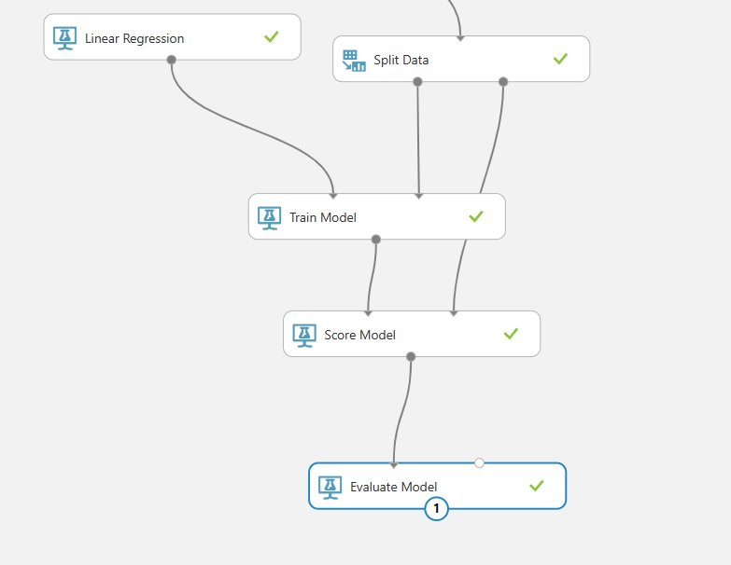

1. Evaluate the model and check the trained model performance

